ACCIDENT PREVENTION SYSTEM
Nidhiyashree.V. K; Nithila Shri. R.P; Sivatharini.R
Department of Electronics and Communication Engineering
PSG Institute of Technology and Applied Research, Coimbatore-641062
21l132@psgitech.ac.in; 21l133@psgitech.ac.in; 21l148@psgitech.ac.in

Abstract- The growing risk of road accidents is of great concern in today’s world. Reports suggest that around 1.3 million people die each year due to road accidents in which 2 lakh people account to India alone. Understating the factors affecting road accident is an important area for road safety research. The aim of this paper is to present the overview of factors influencing the road traffic accident severity and also focuses on providing a solution by a technical innovation. Here an Arduino based system has been developed by integrating Python with Arduino along with python libraries such as cv2(for face detection), numpy (for working with arrays), dlib (for machine learning), imutils (for basic image processing functions), serial and time. The system sends an alert to the driver via buzzer sound, blinking of LED and a message display on LCD screen. The system is of low cost, user friendly and would serve as a great help for accident prevention.
Keywords:- numpy, cv, dlib, imutils, ,time
I INTRODUCTION
In India, 426 people die each day which is approximately 18 per hour. Over 1.55 lakh people has lost their lives in the year 2021. 25% of the accident victims involved are below 16 years of age, another 25% being in the age between 25 and 35 years of age. Speed has been a contributory factor to 60% of the road accidents. Sleep-deprived drivers remain responsible for about 40% of the road accidents, according to enforcement officers patrolling the highways and major roads [1]. There are many factors that cause drowsiness to the drivers. Some of them are job stress, medication, alcohol consumption, untreated sleep disorder, sleep deprivation, etc. Late-night and third-shift workers are particularly affected by the natural release of melatonin associated with dark hours as they journey home after a long shift [2]. Therefore, it has necessary to formulate methods and technologies to prevent accidents especially, the ones caused by drowsy drivers [3]. If immediate action is not taken, road accidents will be the fifth leading cause for death by the year 2030.
II METHODOLOGY
This paper focuses on the detailed description of the methods employed to achieve the stated objectives and demystify the procedure of designing the model of the system. Programming and simulation was used to analyze the model to foretell the effectiveness of the design under study. Computer software was used in the circuit design and simulation of the model of the vehicle accident prevention system using wireless technology. Arduino UNO and Python were used in analyzing the experimental results of this design.
III DESIGN PROCEDURE
The design focuses on the detection of the eye blink using python to prevent vehicular accident whenever the driver becomes drowsy in the process of driving. The python libraries such as Numpy, for working with arrays, dlib, which consists of machine learning library, imutils, that performs translation, rotation and skeletonization, time, that allows pausing program from exiting, serial module, which encapsulates the access for serial port were used.
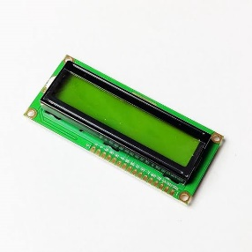
Fig 1:LCD Screen
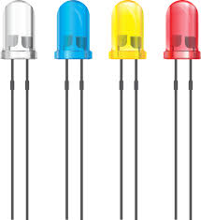
Fig 2: LED Bulbs
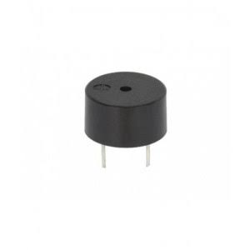
Fig 3: Buzzer

Fig 4: Integration of Arduino with Python
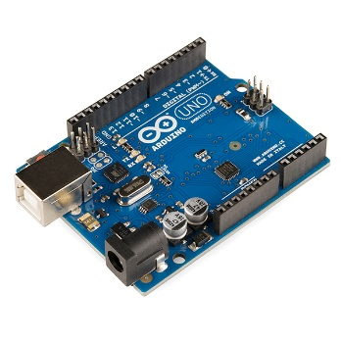
Fig 5: Arduino UNO Board
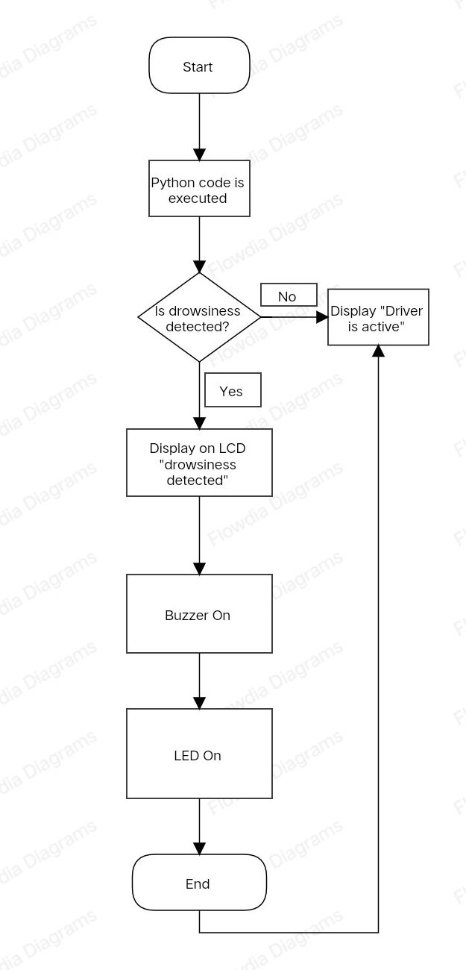
Fig 6: Flowchart on working of the system
The system consists of Python interface which is the brain of the project. It senses the blink of an eye using imutils and cv2 libraries and conveys the message to Arduino using serial library. Upon sensing, the buzzer rings an alarm, the LED starts blinking and the LCD screen displays a message stating, “Drowsy driver” which can be seen by the surrounding vehicles. This enables the drivers of in drowsy state. In this way the system safeguards the driver and prevents from accidents. The system can be further developed by sensing the detection of alcohol consumption by using a MQ-3 sensor.

CONCLUSION
The expanding number of vehicle crashes because of a decreased driver’s carefulness level has turned into significant issue for society. Insights demonstrate that 20% of all car crashes are because of drivers with reduced cautiousness level. Through our system, we can avoid carelessness of drivers and most of vehicles accident.

REFERENCES
[1] J. May and C. Baldwin,” Driver fatigue: The importance of identifying the casual factors of fatigue when considering detection and countermeasure technologies”, Transp.Res. F. Traffic Psychol.Behay, vol 12, n0. 3, pp.218-224,2009
[2] https://www.researchgate.net/publication/336878674_DRIVER_DROWSINESS_DETECTION_SYSTEM
[3] https://www.slideshare.net/PurvanshJain1/driver-drowsiness-detection-report
[4] https://www.ijraset.com/research-paper/driver-drowsiness-detection-using-ml

